ST GREGORY’S CATHOLIC PRIMARY SCHOOL SPORTS PREMIUM REPORT 2022-23

Schools must use the funding to make additional and sustainable improvements to the quality of PE and sport they offer. This means that you should use the Primary PE and Sport Premium to:

- develop or add to the PE and sport activities that your school already offers
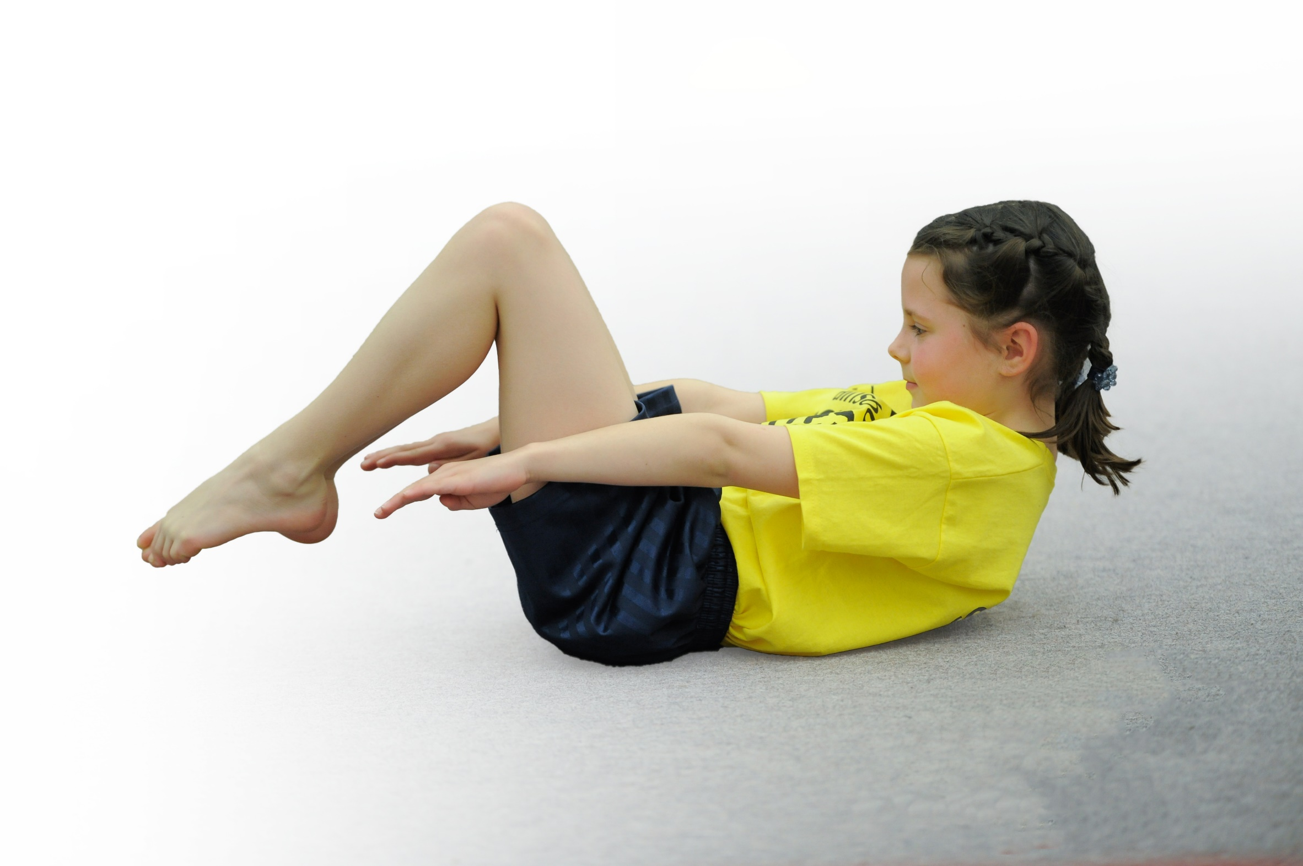
- build capacity and capability within the school to ensure that improvements made now will benefit pupils joining the school in future years

Please visit gov.uk for the revised DfE guidance including the 5 key indicators across which schools should demonstrate an improvement. This document will help you to review your provision and to report your spend. DfE encourages schools to use this template as an effective way of meeting the reporting requirements of the Primary PE and Sport Premium.

We recommend you start by reflecting on the impact of current provision and reviewing the previous spend.
Under the Ofsted Schools Inspection Framework, inspectors will assess how effectively leaders use
the Primary PE and Sport Premium and measure its impact on outcomes for pupils, and how effectively governors hold them to account
for this.

Schools are required to publish details of how they spend this funding as well as on the impact it has on pupils’ PE
and sport participation and attainment.
We recommend regularly updating the table and
publishing it on your website as evidence
of your ongoing review into how you are using the money
to secure maximum, sustainable impact. To see an example of how to complete the table please click HERE.

What development needs are a priority for your setting and your students now and why?

Key achievements to date: | Areas for further improvement and baseline evidence of need:
- Good curriculum coverage from YR – Y6  - Effective use of specialists to teach pupils as well as act as coaches/mentors to staff – dance, gymnastics, multi-sports  - Good range of sporting extra-curricular activities throughout the academic year – majority of pupils, from Yr – Y6 access at least 1 enrichment club a year.  - Good links with All Hallows for regular competitive sporting opportunities, as well as other schools and a competitive sports day.  - Good links with the cross country schools – Autumn, Spring and Summer comps.  - Good links with other schools for football, tag Rugby and Boccia  - Playground equipment, throughout the year, ensures we maximize opportunities for pupils to get a minimum of 30 minutes activity every school day of the year, weather permitting, eg climbing frames, 3 football areas, netball and basketball areas, table tennis table, mini-woodland activities, throwing and catching equipment, skipping ropes, etc  - Most pupils, as a result, are physically active and healthy on a regular basis, not sedentary and therefore, we believe we are maximizing their chances to have ‘healthy minds and healthy bodies.’  - Staff are knowledgeable and skillful. | - We want all 55 pupils currently on roll to participate in at least 1 sporting enrichment club each academic year.  - We want to use our grounds so that they are more accessible all year round to ensure we can maximize activities and participation in these activities  - We need to celebrate all our individual and team achievements to the local press in order to raise the profile of this school even more.  - We need to access more competitive activities in a greater range of sports. For example, netball has diminished this year so needs a boost. Gymnastics could be a strength and needs developing.  - Space. The school is very limited in terms of indoor space. The before and after school club use all the hall space morning and after school every day which seriously limits the expansion of our enrichment programme.  - New resources for playtime needed on an ongoing basis, eg skipping ropes, footballs, basketballs, throwing and catching implements, etc.  - We would like to link with other outside clubs  - We would like to apply for the sportsmark/activemeark award.

Meeting national curriculum requirements for swimming and water safety | Please complete all of the below*:
What percentage of your current Year 6 cohort swim competently, confidently and proficiently over a distance of at least 25 metres? | 100%
What percentage of your current Year 6 cohort use a range of strokes effectively [for example, front crawl, backstroke and breaststroke]? | 100%
What percentage of your current Year 6 cohort perform safe self-rescue in different water-based situations? | 100%
Schools can choose to use the Primary PE and Sport Premium to provide additional provision for swimming but this must be for activity over and above the national curriculum requirements. Have you used it in this way? | Yes
*Schools may wish to provide this information in April, just before the publication deadline.

HOW DID WE SPEND THE FUNDING?

Academic Year: 2021-22 | Total fund allocated: £16,735 | Date Updated: September 2022 |  | Percentage of total allocation:  76%
School focus with clarity on intended impact on pupils: | Actions to achieve: | Funding allocated: | Evidence and impact: | Sustainability and suggested next steps:
All pupils to receive high quality PE lessons during curriculum time and out of school hours/extra-curricular times | Increase the specialists within school and increase the range of activities available out of school hours | Approximately £12,735 | More children are accessing dance, outdoor pursuits, football, Rugby TOTs than ever before.  Lunchtime PE specialist and improved curriculum by ensuring it is well-designed and coherent from EY to Y6. | Continue to look at new and engaging Sports activities for pupils
Key indicator 2: The profile of PE and sport being raised across the school as a tool for whole school improvement |  |  |  | Percentage of total allocation:
 |  |  |  | 6%
School focus with clarity on intended impact on pupils: | Actions to achieve: | Funding allocated: | Evidence and impact: | Sustainability and suggested next steps:
PE/sport is at the heart of what the school endeavours to do. As a result, boys and girls participate in vast numbers. | Every Friday we celebrate a sporting activity or more at our celebration assembly for both activities that are school related or outside of school. We highlight achievements in the weekly newsletter and have even been on ‘Newsround’ February 2019!! | £1000 | Greater proportions of children have participated in out of hours clubs and competitions this year. | We would like to increase our participation in competitions as well as set aside some funding for mental health/well-being initiatives.

Key indicator 3: Increased confidence, knowledge and skills of all staff in teaching PE and sport |  |  |  | Percentage of total allocation:
 |  |  |  | 6%
School focus with clarity on intended  impact on pupils: | Actions to achieve: | Funding  allocated: | Evidence and impact: | Sustainability and suggested  next steps:
Currently, we have staff who could easily deliver high quality PE. Outdoor specialists are used to enhance PE further. | Further continuing professional development in this area is needed through observing specialists and/or through coaching/mentoring as well as organized external PE training sessions. | £1000 | More staff willing to lead an area of sport/PE out of hours in order to deepen and develop children’s knowledge, understanding and skills in a range of sports. | A coherent curriculum needs to be in place and subject specific CPD needs to be accessed for all staff.
Key indicator 4: Broader experience of a range of sports and activities offered to all pupils |  |  |  | Percentage of total allocation:
 |  |  |  | 6%
School focus with clarity on intended  impact on pupils: | Actions to achieve: | Funding  allocated: | Evidence and impact: | Sustainability and suggested  next steps:
Children share with us regularly what activities and achievements in sport they do outside of school. Within school we are continuing to develop dance as well as an outdoor pursuits club and ensuring there is a regular sport opportunity for all pupils in Early Years and Key Stage 1 | Continue with dance and the outdoor club. Continue with a gymnastics club. Re-introduce netball and develop children’s athletics/cricket and tennis skills with more ‘summer’ sport opportunities | £1000 | The dance and the outdoor club have boosted participation levels significantly. | Develop and improve provision for :  - Gymnastics  - Netball  - Summer sports
Key indicator 5: Increased participation in competitive sport |  |  |  | Percentage of total allocation:
 |  |  |  | 6%
School focus with clarity on intended  impact on pupils: | Actions to achieve: | Funding  allocated: | Evidence and impact: | Sustainability and suggested  next steps:
At least once every half term, the school is represented at the high school for a competition, predominantly Year 5/6. Cross country takes place in term 1 and term 4; football games abound in terms 1-4 with tournaments at other times. | Continue with the high school link  Continue with cross country  Continue with football and…  Boost/develop an in-house programme of competitive activities as well as develop our links with Macclesfield SSP | £1000 | Children exposed to more competitive situations, developing team work, learning about winning and losing and how to cope with both, learn from mistakes, improve, work hard and take that learning back into the classroom | Link with Macclesfield SSP  Achieve Sportsmark Award  Develop more in-house competitions (in addition to Sports Day) and provide lunchtime structured activity by employing a PE specialist.

